1. User Datagram Protocol
2. The client sends a message to the server, and the server sends that message back to the client with a timestamp (mimicking the echo behavior of UDP protocol)
3. 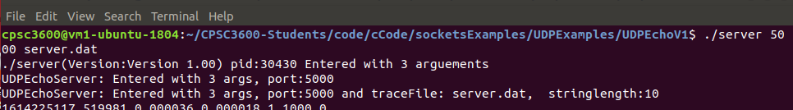

Basically, this is saying that we created a server on port 5000 with trace file server.dat . Now the server is up, and we are ready for clients to start using it.

1. 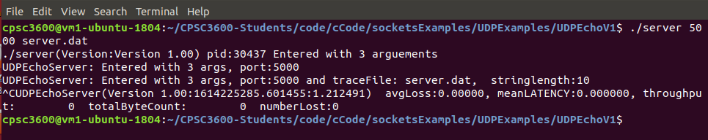

We stopped the server using Control + C. The data here shows that every statistic is zero, but this is only because we never pinged the server with a client.

1. The 5 parameters (in order) are serverip which should be localhost; server port which we use 5000; iteration delay, specifying how long each iteration should wait to ping; message size, specifying how large the messages being sent should be; number of iterations, which we use 0 to mean to keep going until we manually stop it; and the last parameter is the tracefile for client
2. Bind will bind the server side of our code to the IP address and port number specified. This is a socket call that accepts server address and size of a particular server address, where we bind that information to our localhost so that we can create a local server.
3. This will result in an error in the bind call, as the bind call uses particular port addresses which would be the same in both instances.
4. We can alter ECHOMAX by going into the UDPEcho header file and changing the definition to be larger than 10000.
5. DNS stands for Domain Name System.

10- The two main namespaces for the internet are the domain name (DNS) hierarchy and the Internet Protocol (IP) address spaces.